Reconstruction:

Section 1 - Introduction
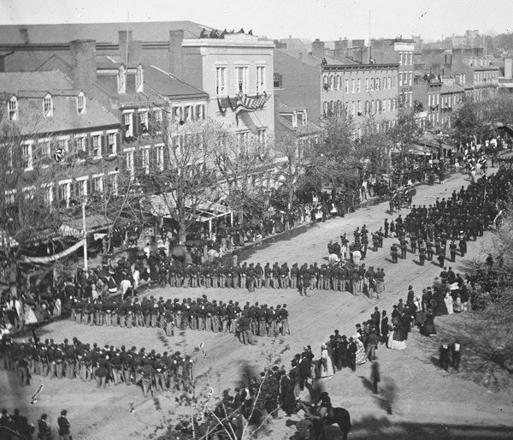
Library of Congress
Five days after the Civil War ended, President Lincoln was shot dead by an assassin. The task of rebuilding the nation fell to Vice President Andrew Johnson, who became president when Lincoln died. Pictured here is Lincoln’s funeral procession from the White House to the Capitol on April 19, 1865.

By the end of the Civil War, Americans longed for peace. But what kind of peace? One that punished the South for its rebellion? A peace that helped rebuild the devastated region? A peace that helped the 4 million African Americans freed from slavery become full and equal citizens? In his second inaugural address, delivered in 1865, President Abraham Lincoln spoke of a healing peace:

With malice [hatred] toward none, with charity for all, with firmness in the right as God gives us to see the right, let us strive on to finish the work we are in, to bind up the nation’s wounds, to care for him who shall have borne the battle and for his widow and orphan, to do all which may achieve and cherish [hold dear] a just and lasting peace
The nation would never know how Lincoln planned to achieve such a peace. On April 14, 1865, just five days after the war ended, the president was assassinated while attending a play at Ford’s Theater in Washington, D.C. The assassin was an actor named John Wilkes Booth. Booth thought that killing Lincoln would somehow save the Confederacy.
After Lincoln’s death, Vice President Andrew Johnson became president. The task of rebuilding the South and bringing the Southern states back into the Union would not be easy for Johnson’s administration. For while the nation was united again, Americans remained deeply divided.
As you read this chapter, think about Lincoln’s dream of “a just and lasting peace.” Did the end of the war and the end of slavery lead to a peace based on liberty and justice for all? Did these events bring African Americans closer to the ideals of liberty and justice, including the rights of citizenship?

Student Notebook Your answer will be sent to your teacher.

- Suppose that you are an emancipated slave in the South at the end of the Civil War. What changes do you hope for your new life? Write about three ways you imagine your life will change now that you have your freedom.

Section 2 - Presidential Reconstruction
As the Civil War ended, people in the United States had sharply different views about how to rebuild the Southern states and bring them back into the Union. This period of time came to be called Reconstruction [Reconstruction: the period of time after the Civil War in which Southern states were rebuilt and brought back into the Union] . For President Andrew Johnson, a Southerner from Tennessee, Reconstruction had two major aims. First, Southern states had to create new governments that were loyal to the Union and that respected federal authority. Second, slavery had to be abolished once and for all.
These aims left many issues to be resolved [resolved: to find a solution for] . For example, who would control the new state governments in the South—former Confederates? Would freed slaves have the same rights as other citizens? And what would the relationship be between freed slaves and former slave owners?
Many Republicans in Congress believed that strong measures would be needed to settle these issues. To them, Reconstruction meant nothing less than a complete remaking of the South based on equal rights and a free-labor economy. The stage was set for a battle over the control—and even the meaning—of Reconstruction.
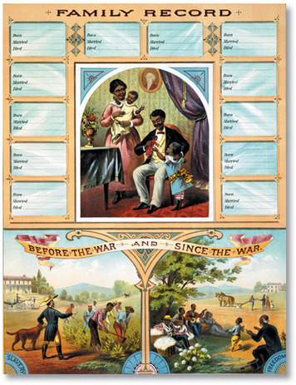
President Johnson’s Reconstruction Plan In May 1865, President Johnson announced his Reconstruction plan. A former Confederate state could rejoin the Union once it had written a new state constitution, elected a new state government, repealed its act of secession, and canceled its war debts. There was a final requirement as well. Every Southern state had to ratify the Thirteenth Amendment [Thirteenth Amendment: a change to the Constitution, ratified in 1865, abolishing slavery in the United States] , which abolished slavery throughout the United States.
By the fall of 1865, every Southern state had met the president’s requirements. The Thirteenth Amendment became part of the Constitution. Presidential Reconstruction had begun.
The Freedmen’s Bureau For former slaves, called freedmen, the freedom guaranteed by the Thirteenth Amendment brought problems as well as opportunities. Frederick Douglass described the freedman as “free from the individual master but a slave of society.” Douglass wrote,
He had neither money, property, nor friends.
He was free from the old plantation, but he had nothing but
the dusty road under his feet . . . He was turned loose,
naked, hungry, and destitute [penniless] to the open sky.
To assist former slaves, Congress established the Freedmen’s Bureau [Freedmen’s Bureau: an agency established by Congress at the end of the Civil War to help and protect newly freed black Americans] in March 1865. Over the next four years, the bureau provided food and medical care to both blacks and whites in the South. It helped freedmen arrange for wages and good working conditions. It also distributed some land in 40-acre plots to “loyal refugees and freedmen.”
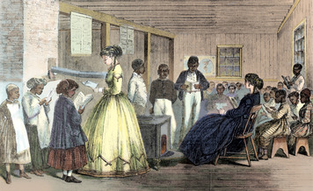
Some whites, however, attacked the bureau as an example of Northern interference in the South. Ultimately, the hope of many freedmen for “forty acres and a mule” died when Congress refused to take land away from Southern whites.

The most lasting benefit of the Freedmen’s Bureau was in education. Thousands of former slaves, both young and old, flocked to free schools built by the bureau. Long after the bureau was gone, such institutions as Howard University in Washington, D.C., continued to provide educational opportunities for African Americans.
Black Codes As new state governments took power in the South, many Republicans in Congress were alarmed to see that they were headed by the same people who had led the South before the war—wealthy white planters. Once in office, these leaders began passing laws known as black codes [black codes: laws passed in 1865 and 1866 in the former Confederate states to limit the rights and freedoms of African Americans] to control their former slaves.
The black codes served three purposes. The first was to limit the rights of freedmen. Generally, former slaves received the rights to marry, to own property, to work for wages, and to sue in court. But they did not have other rights of citizenship. Blacks, for example, could not vote or serve on juries in the South.
The second purpose of the black codes was to help planters find workers to replace their slaves. The codes required freedmen to work. Those without jobs could be arrested and hired out to planters. The codes also limited freedmen to farming or jobs requiring few skills. African Americans could not enter most trades or start businesses.
The third purpose of the black codes was to keep freedmen at the bottom of the social order in the South. Most codes called for the segregation of blacks and whites in public places.

Student Notebook

- What were President Johnson’s two major aims for Reconstruction? Put an asterisk next to the aim that was achieved by the Thirteenth Amendment.

2. Who established the Freedmen’s Bureau, and what was its purpose? List three activities of the bureau that helped it carry out its purpose.

3. Complete the chart to show how new Southern state governments limited African Americans in the South.
Saved!

Purpose | Example

Section 3 - Congressional Reconstruction
As 1865 came to a close, President Johnson announced that Reconstruction was over. The Southern states were ready to rejoin the Union.
A group of Republicans in Congress did not agree with Johnson. Known as the Radical Republicans, these lawmakers had an additional goal for Reconstruction. They believed that the South would not be completely rebuilt until freedmen were granted the full rights of citizenship.
Radical Republicans wanted the federal government to take a more active role in Reconstruction—a role that would involve tougher requirements for restoring Southern governments. In the House of Representatives, Thaddeus Stevens of Pennsylvania led the Radical Republicans. In the Senate, they were led by Charles Sumner of Massachusetts.
Early in 1866, Radical Republicans joined with more moderate lawmakers to enact two bills designed to help freedmen. The first extended the life of the Freedmen’s Bureau. The second was the Civil Rights Act of 1866. It struck at the black codes by declaring freedmen to be full citizens with the same civil rights [civil rights: the rights guaranteed by the Constitution to all people as citizens, especially equal treatment under the law] as whites. Johnson declared both bills unconstitutional and vetoed them. An angry Congress overrode his vetoes.
The Fourteenth Amendment To further protect the rights of African Americans, Congress approved the Fourteenth Amendment [Fourteenth Amendment: a change to the Constitution, ratified in 1868, granting citizenship to anyone born in the United States and guaranteeing all citizens equal protection of the law] . This amendment granted citizenship to “all people born or naturalized in the United States.” It also guaranteed all citizens “the equal protection of the laws.” This meant that state governments could not treat some citizens as less equal than others.
President Johnson opposed the Fourteenth Amendment and called on voters to throw Republican lawmakers out of office. Instead, Republican candidates won a two-thirds majority in both houses of Congress in the 1866 election. From then on, Congress controlled Reconstruction.
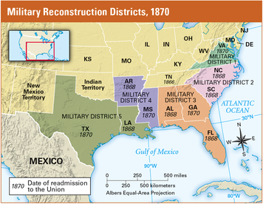
Military Reconstruction Act Early in 1867, Congress passed the Military Reconstruction Act. Once again, it did so over Johnson’s veto. This plan divided the South into five military districts, each governed by a general supported by federal troops. The state governments set up under Johnson’s Reconstruction plan were declared illegal. New governments were to be formed by Southerners loyal to the United States—both black and white. Southerners who had supported the Confederacy were denied the right to vote.
Congress also passed two acts designed to reduce Johnson’s power to interfere with congressional Reconstruction. The Command of the Army Act limited his power over the army. The Tenure of Office Act barred him from firing certain federal officials without the Senate’s consent. President Johnson blasted both laws as unconstitutional. Then, to prove his point, he fired one of the officials protected under the Tenure of Office Act.
President Johnson Is Impeached The House of Representatives responded to Johnson’s challenge by voting to impeach the president. Besides violating the Tenure of Office Act, the House charged, Johnson had brought “the high office of the President of the United States into contempt, ridicule, and disgrace, to the scandal of all good citizens.”
During his trial in the Senate, the president’s lawyers argued that Johnson’s only “crime” had been to oppose Congress. If he were removed from office for that reason, they warned, “no future President will be safe who happens to differ with a majority of the House and Senate.”
Two-thirds of the Senate had to find the president guilty to remove him from office. Despite heavy pressure to convict him, 7 Republicans and 12 Democrats voted “not guilty.” Johnson escaped removal from office by one vote, but he had lost his power.
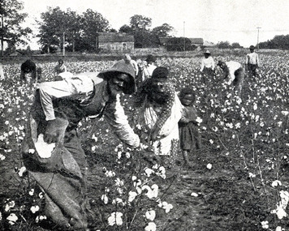
Sharecropping While Congress and the president battled over Reconstruction, African Americans in the South worked to build new lives. Most former slaves desperately wanted land to farm but had no money to buy it. Meanwhile, former slave owners needed workers to farm their land but had no money to pay them. Out of the needs of both groups came a farming system called sharecropping.
Planters who turned to sharecropping divided their land into small plots. They rented these plots to individual tenant farmers—farmers who paid rent for the land they worked. A few tenants paid the rent for their plots in cash. But most paid their rent by giving the landowner a portion of what they raised. This payment of crops was called a share. Usually it was about a third or a half of the tenant’s crop.
Sharecropping looked promising to freedmen at first. They liked being independent farmers who worked for themselves. In time, they hoped to earn enough money to buy a farm of their own.
However, most sharecroppers had to borrow money from planters to buy the food, seeds, tools, and supplies they needed to survive until harvest. Few ever earned enough from their crops to pay back what they owed. Rather than leading to independence, share-cropping usually led to a life-time of poverty and debt.

Interactive Student Notebook Your answer will be sent to your teacher.
- 1. How did the Radical Republicans’ aim for Reconstruction differ from President Johnson’s? What two new laws passed by Congress helped them achieve this aim?
Saved!
- 2. Place an adjective on the line to describe the relationship between Congress and President Johnson during presidential Reconstruction. In each oval, give an example of this relationship.
Saved!
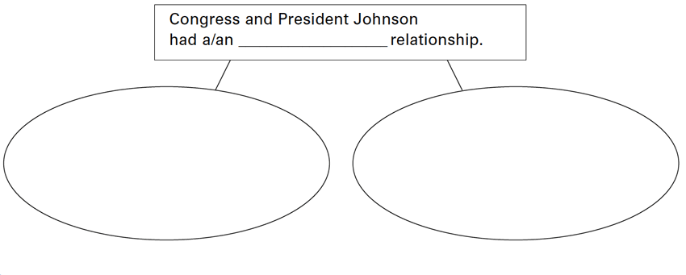
- 3. Why did the House of Representatives impeach President Johnson? What was the outcome of the impeachment trial?

- 4. Why did many sharecroppers end up in poverty and debt?

Section 5 - The End of Reconstruction
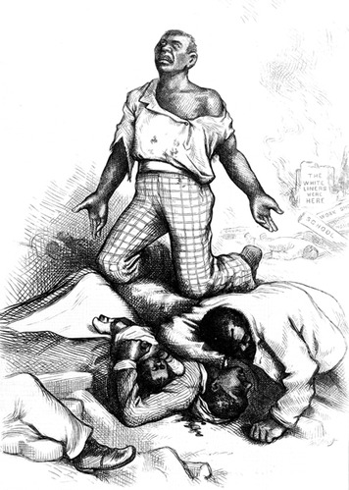
Most whites in the South bitterly resented the Southern Reconstruction governments. They hated the fact that these governments had been “forced” on them by Yankees.
Many taxpayers also blamed their soaring tax bills on corruption—the misuse of public office for personal gain—by the South’s new leaders. While some Southern officeholders did line their pockets with public funds, most, whether black or white, were honest, capable leaders. Still, when taxes increased, opposition to the new state governments increased as well.
But what bothered many Southerners most about their Reconstruction governments was seeing former slaves voting and holding public office. Across the South, Democrats vowed to regain power and return their states to “white man’s rule.”
Violence Against African Americans At first, Democrats tried to win black voters away from the Republican Party. When that tactic failed, they attempted to use legal means to keep blacks from voting or from taking office. In Georgia, for example, the legislature refused to seat elected black lawmakers until they were forced to by the state supreme court. When legal methods failed, whites turned to violence.
Throughout the South, whites formed secret societies to drive African Americans out of political life. The most infamous of these groups was the Ku Klux Klan. Dressed in long, hooded robes and armed with guns and swords, Klansmen did their work at night. They started by threatening black voters and officeholders. African Americans who did not heed their threats were beaten, tarred and feathered, and even murdered.
The Enforcement Acts In 1870 and 1871, Congress passed three laws to combat violence against African Americans. Known as the Enforcement Acts, these laws made it illegal to prevent another person from voting by bribery, force, or scare tactics.
President Grant sent troops into the South to enforce these acts. Hundreds of people were arrested for violence against blacks. Those who were brought to trial, however, were seldom convicted. Few witnesses and jurors wanted to risk the Klan’s revenge by speaking out against one of its members.
The Amnesty Act of 1872 By this time, most Northerners were losing interest in Reconstruction and the plight of the freedmen. It was time, many people said, to “let the South alone.”
One indication of this changing attitude was the passage of the Amnesty Act of 1872. Amnesty means forgiveness for past offenses. The Amnesty Act allowed most former Confederates to vote once again.
The effects of the Amnesty Act were seen almost immediately. By 1876, Democrats had regained control of all but three states in the South. Republicans clung to power in South Carolina, Louisiana, and Florida, but only with the help of federal troops.
The Disputed Election of 1876 In 1876, Americans went to the polls to choose a new president. The Democrats nominated New York governor Samuel J. Tilden as their candidate. Rutherford B. Hayes was the Republican nominee. When the votes were counted, Tilden won a majority of popular votes and 184 electoral votes, just one short of the 185 needed for election. Hayes received 165 electoral votes. Twenty electoral votes from four states were in dispute.
Congress, which was controlled by Republicans, appointed a commission to decide which candidate should get the disputed electoral votes. The commission awarded all 20 to Hayes, giving him exactly the 185 electoral votes he needed to win. The Democrats threatened to block the commission’s decision. Inauguration day grew near with no new president in sight.
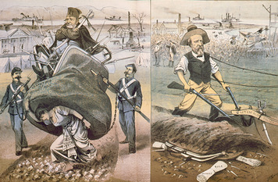
The Compromise of 1877 After weeks of negotiation, Democratic and Republican leaders in Congress agreed to a compromise. The Democrats accepted the electoral commission’s decision, allowing Hayes to become president. In return, Hayes agreed to withdraw the remaining federal troops still occupying Southern states.
Once President Hayes withdrew all remaining federal troops from the South in 1877, Reconstruction was officially over. After that, Democrats quickly took control of the last Southern states. “This is a white man’s country,” boasted South Carolina senator Ben Tillman, “and white men must govern it.”
Most white Southerners celebrated the end of Reconstruction. But for freedmen, the return of the South to “white man’s rule” was a giant step backward. “The whole South—every state in the South,” observed a Louisiana freedman, “has got into the hands of the very men that held us as slaves.”

Student Notebook

1. Complete the flowchart to show the development and effects of violence against African Americans in the South.
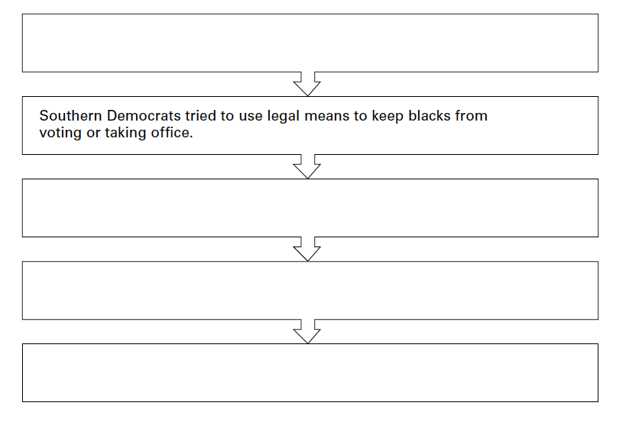
2. What was the dispute in the presidential election of 1876? How was it resolved?

- How did the 1876 election affect African Americans in the South?

Section 6 - Reconstruction Reversed
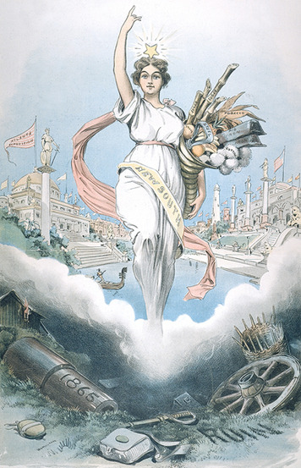
With Reconstruction over, Southern leaders talked of building a “New South” humming with mills, factories, and cities. Between 1880 and 1900, the number of textile mills in the South grew rapidly. Birmingham, Alabama, became a major iron-making center. Still, most Southerners, black and white, remained trapped in an “Old South” of poverty.
Losing Ground in Education During Reconstruction, freedmen had pinned their hopes for a better life on education provided by the South’s first public schools. When Southern Democrats regained control of states, however, they cut spending on education. “Free schools are not a necessity,” explained the governor of Virginia. Schools, he said, “are a luxury . . . to be paid for, like any other luxury, by the people who wish their benefits.”
As public funding dried up, many schools closed. Those that stayed open often charged fees. By the 1880s, only about half of all black children in the South were attending school.
Losing Voting Rights Southern Democrats also reversed political gains made by freedmen after the war. Many Southern states passed laws requiring citizens who wanted to vote to pay a poll tax. The tax was set high enough that voting, like education, became a luxury that many black Southerners could not afford.
Some Southern states also required citizens to pass a literacy test to show they could read before allowing them to vote. These tests were designed so that any African American, regardless of his education, would fail.
In theory, these laws applied equally to blacks and whites and, for that reason, did not violate the Fifteenth Amendment. In practice, however, whites were excused from paying poll taxes or taking literacy tests by a so-called [so-called: commonly described as] “grandfather clause” in the laws. This clause said the taxes and tests did not apply to any man whose father or grandfather could vote on January 1, 1867. Since no blacks could vote on that date, the grandfather clause applied only to whites.
African Americans protested that these laws denied them their constitutional right to vote. The Supreme Court, however, found that the new voting laws did not violate the Fifteenth Amendment because they did not deny anyone the right to vote on the basis of race.
Drawing a “Color Line” During Reconstruction, most Southern states had outlawed segregation in public places. When Democrats returned to power, they reversed these laws and drew a “color line” between blacks and whites in public life. Whites called the new segregation acts Jim Crow laws [Jim Crow laws: laws enforcing segregation of blacks and whites in the South after the Civil War] . Jim Crow was a black character in an entertainer’s act in the mid-1800s.
Not all white Southerners supported segregation. When a Jim Crow law was proposed in South Carolina, a Charleston News and Courier editorial tried to show how unjust it was by taking segregation to ridiculous extremes.
If there must be Jim Crow cars on railroads, there should be
Jim Crow cars on the street railways. Also on all passenger boats
. . . There should be Jim Crow waiting saloons [waiting rooms]
at all stations, and Jim Crow eating houses . . . There should be
Jim Crow sections of the jury box, and a separate Jim Crow . . .
witness stand in every court—and a Jim Crow Bible for colored
witnesses to kiss.
Instead of being a joke, as intended, most of these ridiculous suggestions soon became laws.
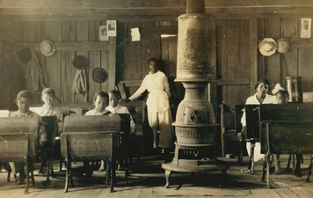
Plessy v. Ferguson African Americans argued that segregation laws violated the Fourteenth Amendment’s guarantee of equal protection of the laws. Homer Plessy, who was arrested for refusing to obey a Jim Crow law, took his protest all the way to the Supreme Court.
The Supreme Court decided his case, Plessy v. Ferguson, in 1896. The majority of the Supreme Court justices found that segregation laws did not violate the Fourteenth Amendment as long as the facilities available to both races were roughly equal. Justice John Marshall Harlan, a former slaveholder, disagreed. In his dissenting opinion, he wrote, “Our Constitution is color blind, and neither knows nor tolerates [tolerates: to put up with] classes among citizens.”
After the Supreme Court’s decision in Plessy, states passed additional Jim Crow laws. Blacks and whites attended separate schools, played in separate parks, and sat in separate sections in theaters. Despite the Court’s decision that these separate facilities must be equal, those set aside for African Americans were almost always inferior [inferior: of less importance, value, or quality] to facilities labeled “whites only.”

Student Notebook

- 1. How did Southern Democrats reverse gains made during Reconstruction in each of these areas?
• Education:
• Voting rights:
• Segregation:

2. Make a sketch to illustrate the results of Plessy v. Ferguson. Include a caption that explains the Supreme Court’s decision in the case and the consequences of that decision.

Saved!

Section 7 - Responding to Segregation
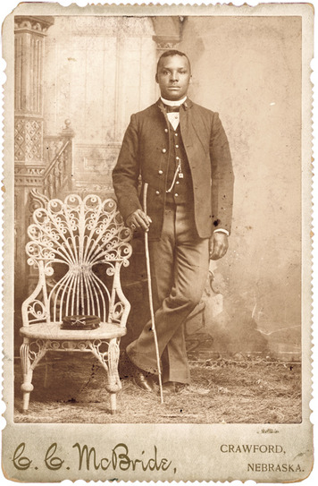
African Americans responded to segregation in many ways. The boldest protested openly. Doing so, however, was dangerous. Blacks who spoke out risked being attacked by white mobs. Some were lynched, or murdered, often by hanging, for speaking out against “white rule.” During the 1890s, an African American was lynched somewhere in the United States almost every day.
African American Migration Thousands of African Americans responded to segregation by leaving the South. A few chose to return to Africa. In 1878, some 200 Southern blacks chartered a ship and sailed to Liberia, a nation in West Africa that had been founded in 1821 for the settlement of freed American slaves.
Many more African Americans migrated to other parts of the United States. Not only were they pushed from the South by racism and poverty, but they were pulled by the lure of better opportunities and more equal treatment. Some sought a new life as wage earners by migrating to cities in the North. There, they competed for jobs with recent immigrants from Europe and often faced racism, if not Southern- style segregation. Others headed to the West, where they found work as cowboys and Indian fighters. Two all-black U.S. Cavalry units known as the Buffalo Soldiers fought on the front lines of the Indian wars. Some blacks found new homes with American Indian nations.
Thousands of black families left the South for Kansas in the Exodus of 1879. The “exodusters,” as the migrants were known, faced many hardships on their journey west. Bands of armed whites patrolled roads in Kansas in an effort to drive the migrants away. Still, the exodusters pushed on, saying, “We had rather suffer and be free.”
Self-Help Most African Americans, however, remained in the South. They worked hard in their families, churches, and communities to improve their lives. While most blacks farmed for a living, a growing number started their own businesses. Between 1865 and 1903, the number of black-owned businesses in the South soared from about 2,000 to 25,000.
Families, churches, and communities also banded together to build schools and colleges for black children. Because of these efforts, literacy among African Americans rose rapidly. When slavery ended in 1865, only 5 percent of African Americans could read. By 1900, more than 50 percent could read and write.

Student Notebook

1. List two factors that pushed African Americans out of the South after Reconstruction and two factors that pulled them toward the North.
Saved!
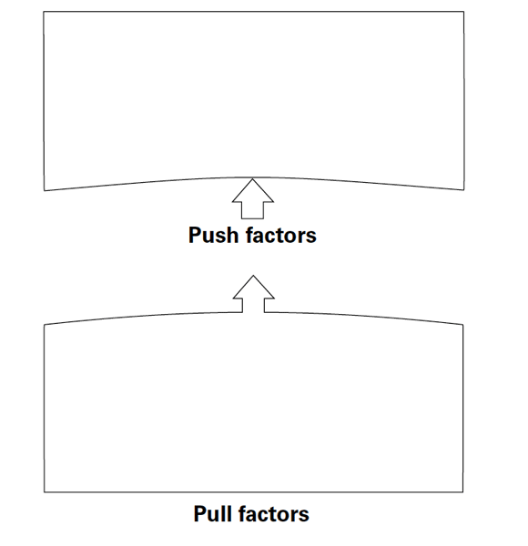 2. Write one sentence to describe the experience of African Americans in each region at the end of the 1800s.
• The North:
• The West:
• The South:

Summary
In this chapter, you learned about the period of Reconstruction in the South from 1865 to 1877.
Presidential Reconstruction Under President Johnson’s Reconstruction plan, every Southern state rejoined the Union after it had written a new constitution, elected a new state government, cancelled its war debts, and ratified the Thirteenth Amendment, which abolished slavery.
Congressional Reconstruction Congressional Reconstruction began in 1866, when Republican leaders in Congress worked to give freedmen the full rights of citizenship. Congress passed, and the states ratified, the Fourteenth Amendment, which gave citizenship to all people born in the United States and equal protection of the law to all citizens.
Southern Reconstruction Under the Military Reconstruction Act, federal troops returned to the South in 1867 and began registering voters. New Southern voters helped former Union general Ulysses S. Grant become president. In 1869, Congress passed the Fifteenth Amendment, which protected the right of African American men to vote. Many blacks were elected to state government offices during this third phase of Reconstruction.
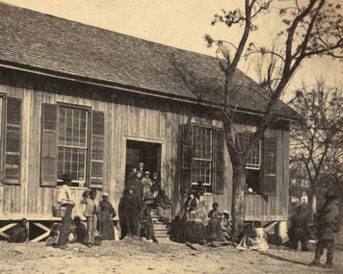
The End of Reconstruction Southern whites used legal means as well as violence to keep blacks from voting or taking office. Reconstruction officially ended in 1877, when President Rutherford B. Hayes withdrew all remaining federal troops from the South once he took office after the disputed election of 1876.
Reconstruction Reversed After Reconstruction, African Americans lost educational and political gains. Many Southern states closed schools that had been opened to freedmen. They also passed laws designed to keep blacks from voting. Jim Crow laws and the Supreme Court’s decision in Plessy v. Ferguson legalized many forms of discrimination against blacks.
Responding to Segregation Many African Americans responded to segregation by leaving the South. Many migrated to other parts of the United States. Those who remained in the South worked hard to improve their lives.

- Create an illustration of a road that shows the important events of Reconstruction and their impact on African Americans’ journey toward full citizenship.

- Your road should
• show the progress and setbacks that African Americans experienced in their struggle for full citizenship during Reconstruction. For example, hills, twists, and turns away from full citizenship might show setbacks, while straight paths and bridges might show progress.
• include symbols, pictures, and labels for at least two events from each phase of Reconstruction. Stop signs, potholes, and roadblocks might show events that prevented progress toward full citizenship. High-speed-limit signs or freeway signs might show events that helped African Americans to achieve their goals.
• include at least six Key Content Terms.
• have a caption summarizing to what extent Reconstruction brought African Americans closer to full citizenship.
• be colorful and free of spelling errors.

Reading Further - The Long Road to Equal Rights
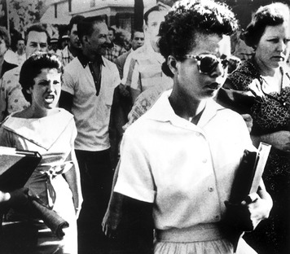
During Reconstruction, Congress added three amendments to the Constitution to guarantee equal rights to African Americans. Still, it took another 100 years and large-scale political action to make those guarantees real.
The station wagon rolled down West 28th Street in Little Rock, Arkansas. It was part of a convoy, with one jeep in front of it and another behind. Each jeep carried soldiers and a machine gun. Each soldier carried a rifle. In the station wagon, nine high school students sat nervously. It was their first day of school at Little Rock’s Central High School.
More soldiers waited at the school for the convoy to arrive. One of the students, Ernest Green, recalled that frightening moment.
The whole school was ringed with paratroopers and helicopters
hovering around. We marched up the steps . . . with this circle of
soldiers with bayonets drawn.
It was 1957. The students, who came to be known as the Little Rock Nine, would be the first African Americans to attend the city’s all-white Central High School.
The students had tried to enter the school twice before, just a few weeks earlier, but had met fierce resistance. Many of Little Rock’s white citizens were determined to keep them out. Melba Pattillo, one of the students, described what she went through.
On the first day, the kinds of things that I endured were parents
kicking, parents hitting, parents throwing things. You would get
tripped; people would just walk up and hit you in the face. And
you couldn’t hit back.
On those first days, police had escorted the Little Rock Nine into a side entrance of the school building. But the principal had sent the nine students home. He said he feared for their safety.
The third time the Little Rock Nine began their school year, they did so with military protection. On national television that night, President Dwight Eisenhower explained why. “I have today issued an executive order directing the use of troops under federal authority to aid in the execution of federal law at Little Rock.” The federal law that Eisenhower referred to was the law to integrate public schools. The military would be sure it was obeyed.
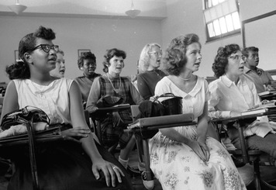

The Fourteenth Amendment Comes of Age
Efforts to integrate public schools began long before the Little Rock Nine entered Central High. In a sense, they began in 1868 during Reconstruction. That is when the Fourteenth Amendment was ratified.
It said that no state could limit privileges or deny any American equal protection under the law. The amendment guaranteed freed slaves the same rights that white Americans had.
Unfortunately, that guarantee was soon modified. In 1896, the Supreme Court held that it was legal to segregate public places. As long as facilities for blacks were equal to those for whites, the court said, segregation did not violate the Fourteenth Amendment. So, under this doctrine of “separate but equal,” segregation continued. Although the Constitution guaranteed equal rights, African Americans would have to fight to exercise those rights.
Focused efforts to end segregation in schools began in the 1930s. The long haul toward school integration began with a vision. A young African American lawyer named Charles Houston believed that the way to get equal rights was for black lawyers to challenge segregation in court. But there were very few black lawyers at the time. Most law schools were segregated or accepted only a few black students. But Houston had a plan. At the historically black Howard University in Washington, D.C., Houston trained a generation of black lawyers. Among them was his star pupil, Thurgood Marshall.
Those lawyers confronted segregation in one case after another for more than 20 years. They started by arguing against segregated law schools and then segregated graduate schools. It was not until the 1950s that they took on the segregated public schools.
Their efforts culminated in the 1954 Supreme Court case Brown v. Board of Education of Topeka, Kansas. In their decision, the Court held that separate schools could never be equal. This meant that public schools would have to integrate. Three years later—nearly 90 years after the Fourteenth Amendment was added to the Constitution—the Little Rock Nine, under armed guard, followed that law and entered Central High School.
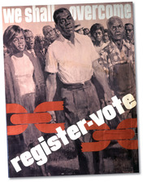

The Fifteenth Amendment Comes of Age
The struggle to integrate schools and other public places did not end at Central High. There would be other battles to win for African Americans to have equal rights. In 1963, to mark 100 years since Abraham Lincoln had emancipated the slaves, more than 200,000 people marched to the steps of the Lincoln Memorial in Washington. At that historic event, Martin Luther King Jr. spoke of the work that was still unfinished.
Five score [one hundred] years ago, a great American, in whose
symbolic shadow we stand today, signed the Emancipation Proclamation
. . . But one hundred years later, we must face the tragic
fact that the Negro is still not free. One hundred years later,
the life of the Negro is still sadly crippled by the manacles of segregation
and the chains of discrimination. One hundred years later,
the Negro lives on a lonely island of poverty in the midst of a vast
ocean of material prosperity [wealth]. One hundred years later,
the Negro is still languishing [suffering] in the corners of American
society and finds himself in exile in his own land.
Voting rights, like integration, had been promised after the Civil War, but that promise had not been fulfilled when King spoke in 1963. The Fifteenth Amendment, which was ratified in 1870, granted African Americans the right to vote. But in the 1960s, very few black citizens in the South were able to exercise that right.
The reason? Laws in many Southern states made voting impossible for most African Americans. Some places had literacy tests, for example. Anyone who could not read and write was not allowed to register to vote. The tests were often rigged with questions no one could answer, so that even literate blacks could not pass them. Taxes and property requirements were other methods that made it impossible for most African Americans to exercise their right to vote.
That is why, in the 1960s, African Americans were fighting to register to vote in places like Selma, Alabama. In Selma, the registration office was only open two days a month. The workers there often arrived late, left early, and took long breaks. In 1963, only 156 of Selma’s 15,000 eligible black voters were registered.
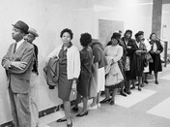
Through 1963 and 1964, black citizens of Selma tried again and again to register to vote. Again and again, the county sheriff and other white leaders tried to stop them. In 1965, the situation in Selma came to a head.
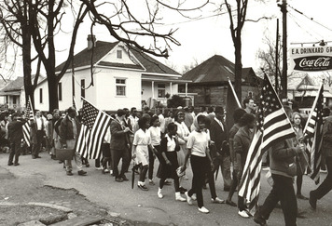
On Sunday, March 7, about 600 people gathered in Selma. They planned to march 50 miles to the state capital in Montgomery to insist on their right to vote. When they reached the Edmund Pettus Bridge, Alabama state troopers ordered them to leave. They stayed. The police advanced. They knocked people to the ground and fired tear gas. Riding horses, the police charged at the marchers.
That day, which came to be called Bloody Sunday, marked a turning point in the struggle for voting rights. On television and in newspapers, images of the violence in Selma reached people across America. Many had not known about the extent of segregation or the violent methods used to enforce it. They were horrified. The mayor of Selma, Joe Smitherman, remembered that the tide turned that day.
When that beating happened at the foot of the bridge, it looked
like war. That went all over the country [on the television news].
And the people, the wrath of the nation came down on us.
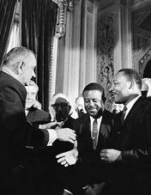
The clashes in Selma continued for days. Then, President Lyndon Johnson put voting rights legislation before Congress. “Their cause must be our cause too,” Johnson said to the American people. “Because it is not just Negroes, but really it is all of us who must overcome the crippling legacy of bigotry and injustice.”
Days later, thousands of people began the march from Selma to Montgomery. Five days after that, 25,000 people gathered at the state capitol in Montgomery. They celebrated their success and braced themselves for the hard work ahead. Later that year, Congress passed the historic Voting Rights Act of 1965. The act supported the rights that the Constitution had promised blacks nearly 100 years earlier.
Some historians say that the civil rights movement of the 1950s and 1960s was a “Second Reconstruction.” They point out that the three Reconstruction amendments—the Thirteenth, Fourteenth, and Fifteenth—promised equal rights to African Americans. Yet, it took another century for those rights to be realized.

Student Notebook

- Preparing to Write: Identifying Values
In 1965, President Lyndon Johnson told the U.S. Congress that the struggle of African Americans in Selma was a struggle shared by the nation. “Their cause must be our cause too,” he said. President Johnson expressed his values by saying that it was important for all Americans to be able to exercise their civil rights.
What values were the Little Rock Nine expressing by integrating Central High School?

- What values did Charles Houston act on when he trained black lawyers?

- What values did the Selma marchers express through their actions?

- Writing a Personal Statement
The right to vote is one of the most important values in a democratic nation. Americans have fought and died to defend that right. American citizens are able to exercise their right to vote when they are 18 years old.
Write a statement expressing your personal beliefs about the value of the right to vote. Offer two reasons why voting is important in a democracy. Tell whether you intend to vote when you are 18, and explain the reasons for your answer.

