Lesson 23 : Tensions in the West

Geography Challenge - Migration and Industry

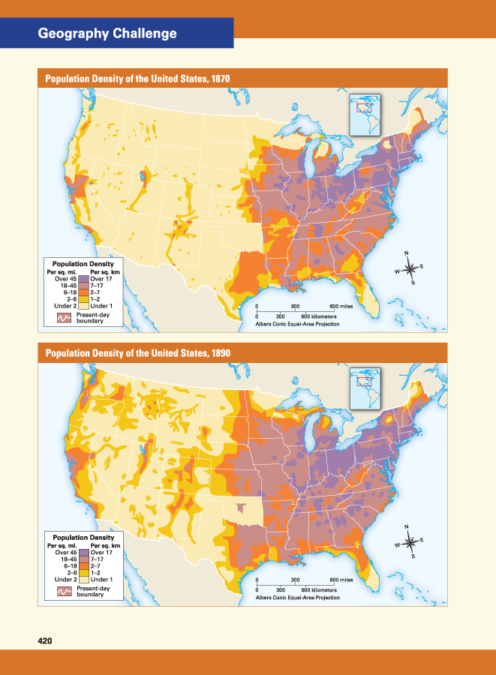

Industry and agriculture grew steadily in the decades after the Civil War. Mining, ranching, and farming boomed on the Great Plains and farther west. So did manufacturing in the East. The key to this growth, and the link that connected the nation geographically, was the railroad.
The map on this page shows the nation’s main railroad lines for two different years, 1870 and 1890. Compare railroads in the country by 1870 with railroads by 1890. Notice the difference between the amount and location of track. In fact, the total miles of track in the United States more than tripled between 1870 and 1890.
Think about being a farmer on the Great Plains in 1870. It would be a hard life and, for many, a lonely one. Farm machinery and luxuries such as glass for windows would not be easy to obtain. The cost of transporting such goods from eastern factories by wagon would make them very expensive. But railroads changed that. By 1890, such goods could travel most of the way to the Great Plains by train.

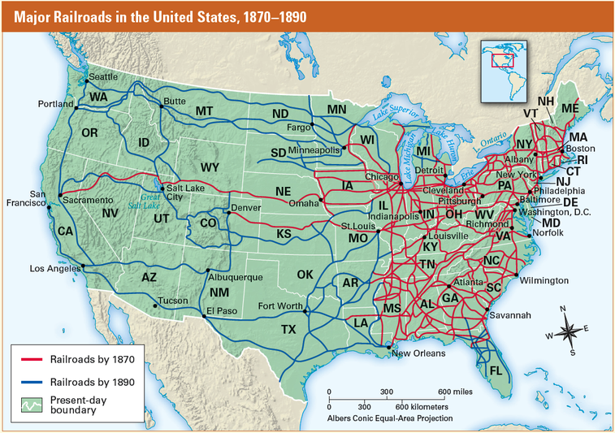

The people, machinery, and other goods that trains carried west spurred the growth of mining, ranching, and farming. The same trains also moved ore, livestock, and farm products east to become raw materials for the nation’s industries. The growth of industry created jobs, and people came to the nation’s industrial cities to fill those jobs.
The maps on the opposite page show the nation’s patterns of settlement in 1870 and 1890. The population changes they show, especially in the West, are almost as dramatic as the changes in the railroad maps. That is because, to a great extent, railroad growth was directly or indirectly responsible for them.

Section 1 – Introduction

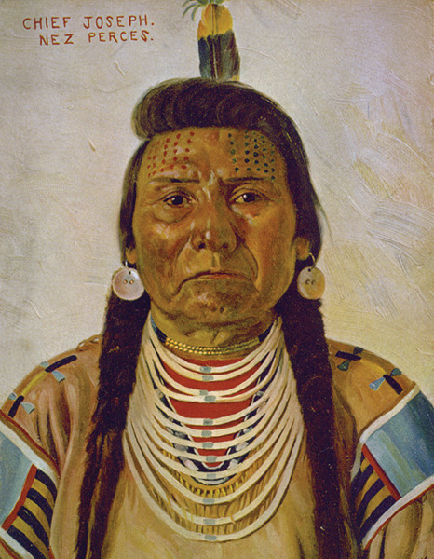
Library of Congress
Chief Joseph became the leader of the Nez Perce Indians in 1871. This portrait was made around 1897.

In the spring of 1889, two white women arrived at the Nez Perce lands in Lapwai, Idaho. One of them, Jane Gay, had nursed soldiers during the Civil War. The other, Alice Fletcher, had been a leader in the growing movement for women’s rights. Now a new cause had brought these women west. They wanted to improve the lives of American Indians.

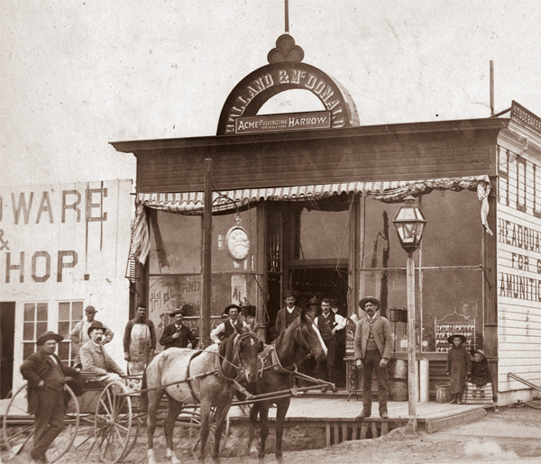
Library of Congress
ranchers Hardware stores, like this one in Nebraska in 1886, supplied tools for farmers and settling in the West. The settlement of the West had a devastating effect on the Indians who lived there.

Gay and Fletcher were just two of the thousands of Americans who moved west after the Civil War. As you have read, during this period politicians in the East were arguing over Reconstruction. Meanwhile, railroad builders, miners, ranchers, and farmers continued to move westward. In this chapter, you will learn how the settlers’ dreams of freedom and opportunity clashed with the dreams of the American Indians who already lived in the West.
The conflict between settlers and Indians was not just a fight over land. It was a conflict between two very different cultures and ways of seeing the world.
Jane Gay and Alice Fletcher discovered these deep differences soon after they arrived at Lapwai. Like other Indians, the Nez Perce had already been forced onto reservations—areas of land set aside by the government—to make way for new settlers. Now Fletcher told the Indians that the government wanted to divide the Lapwai Reservation into farm plots. Each family would receive one plot. Then the Nez Perce could live like other Americans.
The Indians listened in stony silence. Settlers might think of owning a plot of land as a way to be free. But to a Nez Perce, being tied to one spot of earth would be like being in jail.
Finally, one man spoke. “We do not want our land cut up in little pieces,” the Indian said. “We have not told you to do it.”
This Indian’s words show why tensions were bound to develop between settlers and American Indians. As you read about the Nez Perce and other Indian groups, you will discover the great impact that the settlement of the West had on American Indians.

Student Notebook

Write about a time when someone made a promise to you and then broke it. Describe what the promise was, why the person broke the promise, and how you felt when it was broken.

