18.4. Reforming the National Government
Progressives also sought to reform the federal government and its policies. They favored a range of financial reforms that would improve government funding and the banking system. They also worked for constitutional reforms, including the direct election of senators, a ban on alcohol, and women's suffrage.

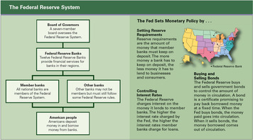

Reforming the Banking System Progressives wanted government to stabilize the banking system. Since the early 1800s, the nation had been shaken by financial panics, periods when people withdrew their money from banks after losing confidence in the economy. Panics caused banks and businesses to collapse and sometimes triggered economic depressions.
Taft urged Congress to reform the banking system, but Americans differed over the proper solution. Progressives wanted government control over the system, while business leaders favored private control. In 1913, Wilson backed a proposal for a government-controlled but decentralized banking system. Congress responded by passing the Federal Reserve Act in 1913.
The Federal Reserve Act divides the country into 12 regions, each with a Federal Reserve Bank. Together, these banks and their operating rules make up the Federal Reserve System, or central bank of the United States. Under this system, private banks remain independent but agree to operate under the rules of the Federal Reserve System, which is also called the Federal Reserve or "the Fed." The Fed offers a safety net to private banks by lending them money if they are short of funds. It also sets monetary policy to regulate the amount of money in circulation, including setting interest rates and regulating how much banks can lend. The Fed has made the financial system much more stable.
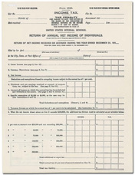
Reforming Taxes and Tariffs As the role of the federal government expanded, its need for revenue to fund its programs increased. Big business favored raising tariffs, but progressives wanted to raise taxes. Tariffs on imports had long been used to boost government revenue. However, progressives believed that they were unfair to consumers. By raising the cost of imported goods, tariffs increased the cost of living for average Americans. A national income tax could be imposed more fairly on all citizens.
Under strong pressure from progressives, and with some support from Taft, Congress proposed the Sixteenth Amendment, which would allow the federal government to impose an income tax. After the amendment was ratified in 1913, during Wilson's presidency, Congress made the tax a graduated income tax, requiring people with higher incomes to pay a larger percentage of their earnings than those with lower incomes. Progressives were pleased because a graduated income tax placed a higher burden on those who had more money. Meanwhile, Wilson pressured Congress to reduce tariffs. Congress put both measures—the graduated income tax and reduced tariffs—into a single bill, the Underwood Tariff Act. Wilson signed it in 1913.
Electing Senators Directly For progressives, reform also meant giving citizens a greater say in their government. One key issue was the election of U.S. senators. The Constitution required that senators be elected by state legislatures. However, state lawmakers and the senators they elected often had close ties to large corporations.
Progressives wanted senators to respond to the will of the people, not the power of big business. Therefore, they pushed Congress to propose the Seventeenth Amendment. Proposed in 1912 and ratified in 1913, the amendment required the direct election of senators by popular vote. This procedure gave average citizens more influence in the Senate.
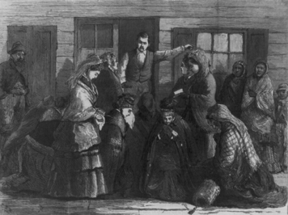

Legislating Morals: Prohibition The widespread public support for prohibition—a ban on the production and sale of alcoholic beverages—was rooted in the temperance movement dating from the early 1800s. Most advocates were women, and the largest organization had been the Women's Christian Temperance Union. The WCTU was founded in 1874. It had reached its peak in 1890, boasting more than 150,000 members. The WCTU argued that drinking alcohol made men unable to support their wives and children.
The WCTU remained influential. However, the leading organization advocating prohibition during the Progressive Era was the Anti-Saloon League, run mainly by men. Founded in 1893 and supported mostly by Protestant churches, it became a national organization in 1895. Its motto was "The Saloon Must Go."
The prohibition movement gained momentum without help from Roosevelt or Taft. Wilson finally supported a constitutional amendment on prohibition after the nation entered World War I in 1917.Proponents had argued that grain was better used for food for the war effort than for making alcohol. The Eighteenth Amendment was ratified in 1919. It declared that the prohibition of "the manufacture, sale, or transportation of intoxicating liquors" would take effect one year after ratification.

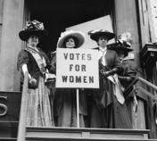

Establishing Women's Suffrage Women had been trying to win the right to vote since before the Civil War. Many temperance activists also supported women's suffrage. They argued that women were more moral than men and that women's involvement would help cleanse the corrupt world of politics.
Like prohibition, the struggle for women's suffrage was a grassroots effort that succeeded without much presidential support. Roosevelt was sympathetic but did not push for the cause until his 1912 campaign. After the nation entered World War I, leading suffragists such as Carrie Chapman Catt emphasized that giving women the right to vote would help them carry out their duties on the home front. Wilson eventually accepted their arguments. He urged Congress to propose an amendment to give women the right to vote as "a vitally necessary war measure." Meanwhile, 26 states had petitioned Congress to propose it.
In 1919, Congress proposed the amendment by decisive votes in both the House and Senate. The Nineteenth Amendment was ratified in 1920. It declared that "the right of citizens of the United States to vote shall not be denied or abridged by the United States or by any state on account of sex."

Student Notebook Activity:

Summarize the progressive reforms made by the national government during each of the three presidencies. Include details from all five subsections somewhere in your matrix.

 | Theodore Roosevelt  1901-1909 | William Taft  1909-1913 | Woodrow Wilson  1913-1921
Reforming the National Government

