18.2. Three Progressive Presidents

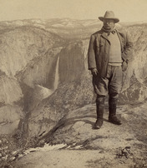
The framers of the Constitution wanted the president to have prestige but not too much power. Many feared what might happen if the chief executive became too powerful. As the presidency evolved during the Progressive Era, Americans began to change not only their ideas about what the national government should do, but also their views about how strong the president should be.
The three presidents of the Progressive Era—Roosevelt, Taft, and Wilson— held office between 1901 and 1921. Although differing in many ways, they shared a commitment to reform. They challenged the economic and political power of the industrial giants and worked to end government corruption. In the process, all three of these leaders expanded the power of the presidency.
Theodore Roosevelt Promises a Square Deal Theodore Roosevelt was vice president under President William McKinley and became president after McKinley was assassinated in 1901. At the age of 42, he was the youngest president in American history. Also known as Teddy or TR, he was a colorful character. He was short and stout with big teeth, and he had a passion for physical fitness. As a member of New York's state assembly in the 1890s, he was known for being impulsive, but he was a shrewd politician who knew how to get things done.
Roosevelt believed that businesses, workers, and consumers should all receive a "square deal"—fair and honest treatment. His program of reform, which became known as the Square Deal, focused on regulating big business and protecting workers and consumers.
Roosevelt believed the country needed a strong president. "I believe in power," he once said. But he thought that presidential power should be used to benefit all Americans. Describing himself as "the steward [caretaker] of public welfare," he asserted that a president should take any actions necessary for the common good, as long as the Constitution did not forbid them.

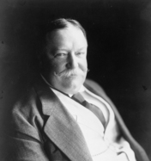
Taft Continues Reforms After Roosevelt served two terms, he supported William Howard Taft, a member of his cabinet and a former judge from Ohio, to succeed him in 1908. Roosevelt was confident that Taft would continue his reform program.
The two men could not have been more different. Roosevelt was outspoken and loved the limelight, while Taft was quiet and reserved. Whereas Roosevelt took bold actions, Taft was cautious. In short, Taft was a reluctant, lackluster campaigner. Nevertheless, Roosevelt's support helped him sail to victory.
As president, Taft continued reform efforts. He fought to limit the power of big corporations and added land to the national forest system. However, on other issues Taft parted company with progressive reformers. Progressives wanted lower tariffs on imported goods. Lower tariffs would make foreign products less expensive for American consumers. They would also increase competition, so that American producers would have to lower prices. Big business favored high tariffs. Taft had campaigned for president on a low-tariff platform, but in 1909 he agreed to sign the Payne-Aldrich Bill, which raised tariffs. This action tarnished Taft's record as a progressive.

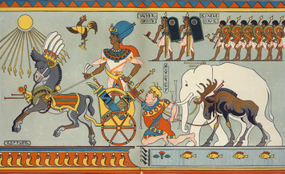

The Election of 1912 The presidential campaign of 1912 centered on progressive reform. Roosevelt believed that Taft had betrayed progressive ideals. For that reason, he decided to run for president again in 1912. When the Republicans chose Taft as their candidate, Roosevelt decided to run as the candidate of a third party, a political party outside the two-party system. Roosevelt's party was called the Progressive Party but was nicknamed the Bull Moose Party after he declared his readiness by exclaiming, "I feel as fit as a bull moose."
The 1912 election also featured two other candidates. Woodrow Wilson, a man of strong progressive ideals, represented the Democratic Party. Labor leader Eugene V. Debs, running on the socialist ticket, advocated more radical change, calling on voters to make "the working class the ruling class."
The split between Taft and Roosevelt helped Wilson win the 1912 election. Wilson received 42 percent of the popular vote. Roosevelt had 27.5 percent, and Taft had 23 percent. Debs was a distant fourth with 6 percent but received almost a million votes, a strong showing for the Socialist Party.

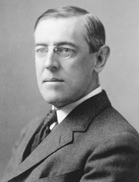
Wilson Promises New Freedom As governor of New Jersey, Wilson had supported progressive reforms to regulate big business and clean up machine politics. As president, this idealist and scholar set out to implement a national reform program that he called New Freedom. Wilson wanted to eliminate all trusts because he believed they were denying economic freedom to small businesses and ordinary citizens. He was unable to remove the trusts, but he did further limit their power.
Wilson pushed through other progressive reforms to give a greater voice to the average citizen, restrict corporate influence, and reduce corruption in the federal government. Among his most notable achievements were laws on banking and tariff reform and the creation of the Federal Trade Commission.
Wilson was the first president since George Washington to speak before Congress, introducing and lobbying for legislation. Like Roosevelt, he also tried to influence, and utilize, public opinion to further his reform goals.

Student Notebook Activity:
Add one or two details about each president’s personality, background, and reform programs to the matrix below.

 | Theodore Roosevelt  1901-1909 | William Taft  1909-1913 | Woodrow Wilson  1913-1921
Personality
Background
Reform Programs

