Lesson 18: Progressives on the National Stage

18.1. Introduction

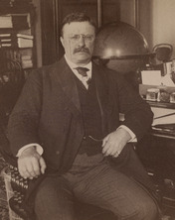

On February 22, 1902, the rich financier J. P. Morgan went to the White House to see President Theodore Roosevelt. Morgan had a dispute to resolve with the president. Roosevelt had recently ordered the Justice Department to file a lawsuit against Northern Securities Company, of which Morgan was part owner, for antitrust violations.
Northern Securities was a holding company, a business that controls other companies by buying up a majority of their stock. Morgan and other businessmen had created this holding company to control the long-distance railroad lines from Chicago to California. By the time the Roosevelt administration filed suit against him, Morgan held a monopoly on rail service in the Northwest.
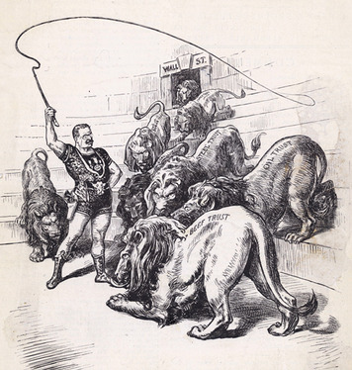
Morgan believed it would be easy for the two men to settle their differences. "If we have done anything wrong, send your man to my man and they can fix it up," he told Roosevelt. But Roosevelt disagreed. He didn't like it when big business treated government as an equal, or worse, as its servant. "That can't be done," he told Morgan. Two years later, in 1904, the Supreme Court ruled against Northern Securities.
"Trustbusting" was one of a number of progressive reforms enacted at the national level in the early 1900s. In addition to local and state issues, progressives were also concerned about problems in the country as a whole. Many of them believed that the national government no longer served the interests of all Americans. In an age when big business seemed all-powerful, many reformers felt the United States was abandoning its promise of freedom and opportunity for all. They wanted the government to play a stronger role in promoting democracy and solving national problems.
Three presidents—Theodore Roosevelt, William Howard Taft, and Woodrow Wilson—worked to advance the progressive reforms. Their efforts helped change how Americans thought, and continue to think, about the role of government.

Student Notebook Activity:

- Closely examine the political cartoon in this section of the Student Text. Then answer these questions:

1. What are the three most interesting details you see?

- 2. What do the lions represent?
- 3. This cartoon is titled "The Lion Tamer." The lion tamer is President Theodore Roosevelt. Based on the cartoon, what might his personality be like?
- 4. Does the cartoonist seem to believe that President Roosevelt will be able to control the trusts?
- 5. Based on the cartoon, how might the federal government's power over trusts have changed during Roosevelt's presidency?

