3. The Revolution Spreads
Industrialization steadily improved Great Britain’s economy. It increased the amount of goods produced and greatly raised worker productivity [productivity: the amount of goods or services that result for each unit of required resources used (output per unit of input)] , or the amount of goods each worker, on average, produced. Wealth generated by industrialization enhanced the standard of living for many people. It also made more tax revenue available to the government. Competing nations took notice and sought to develop their own industries. Generally, they adopted the elements of the British model that suited their circumstances.
Belgium Belgium, located across the English Channel from Great Britain, was the second country to take part in the Industrial Revolution. Belgium borrowed techniques and technology from the British, but its industrialization followed a different pattern. The people of Belgium had long been known for their woolen textile industry. By 1820, they had begun to mechanize that industry. But the traditional hand weaving of complex designs persisted into the mid-1800s. Belgium’s textile industry grew, but not as fast as Great Britain’s.
Belgium’s industrialization focused more on its abundant reserves of coal and iron ore. Exports of coal brought in valuable revenue, and the coal itself fueled the iron-making process. Belgium used the iron to produce machinery, locomotives, ships, and weapons. Later, Belgium developed a thriving steel industry.

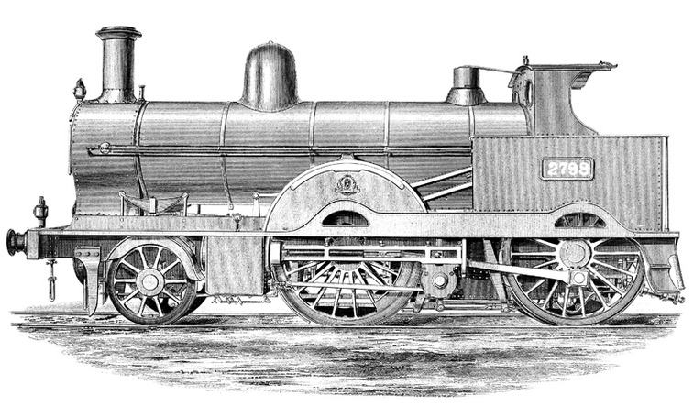
© David Bukach
Belgium was the second country to industrialize. Belgium used its abundant coal reserves to make iron, which was then used to produce machinery, locomotives such as the one seen here, ships, and weapons.
France France, with the help of British equipment, entrepreneurs, and engineers, also began to industrialize in the 1820s. It established numerous textile mills for the production of cotton cloth. Other factories produced machinery, including steam engines. France later had to import coal from Great Britain and from Belgium, because it lacked significant reserves of its own. As a result, France’s factories relied more on waterpower than steam power.
The United States As in France, early industry in the United States depended on waterpower, abundant in New England. Cotton textile mills mushroomed in New England in the 1820s. The mills modeled their technology and organization on those of British factories. Like the British, New Englanders’ raw cotton came from the American South.
New England factories also made metalwork. They used specialized equipment to produce metal parts for machinery and for guns. They owed their success to the earlier work of Eli Whitney and Simeon North, who established a method of manufacturing interchangeable parts [interchangeable parts: parts that can be swapped for one another in the assembling of a product, because they have been precisely cut and shaped to be identical] . These inventors devised machine tools that could cut, plane, and drill part after part to nearly the exact same size and shape. The use of interchangeable parts allowed the rapid assembly of machines or other complex devices in a factory, based on a series of simple operations.
Further innovations sparked the Industrial Revolution in the United States. One was the cotton gin, another accomplishment of Eli Whitney. His machine for cleaning cotton led to a vast Southern expansion of cotton production—and slavery. The Bessemer process [Bessemer process: a relatively inexpensive method for converting iron to steel by using a blast of air to remove carbon from molten iron] , an inexpensive way to convert iron into higher quality steel, greatly increased steel production. Cheap steel helped the heavy industries of the American Midwest to expand. They used the region’s plentiful iron ore and coal to build steel plants and factories that produced machinery and railroad rails—and the steel girders that, in the 1880s, made possible the first true skyscrapers.

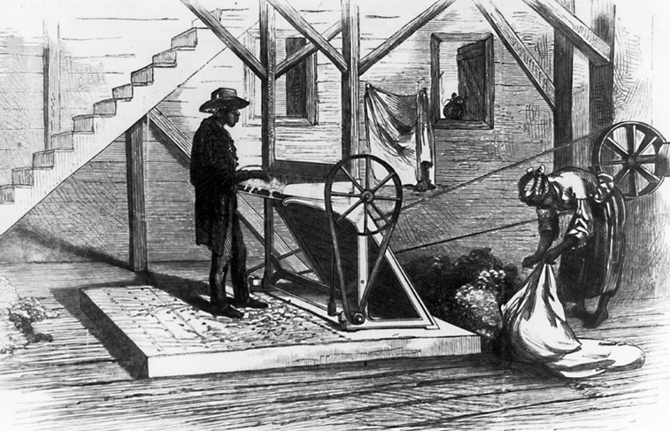
Library of Congress
The American Eli Whitney invented the cotton gin (short for cotton engine) in 1793. Here two slaves are shown operating a cotton gin, which mechanically separated the cotton fiber from the seed.
The heart of any factory was its machinery, and machinery has moving parts that interact. Without lubrication, that machinery would overheat and eventually grind to a halt. Through much of the 1800s, workers lubricated their machines with whale oil. In the 1850s, scientists developed a new and less expensive lubricant—coal oil.
Then, in 1859, an entrepreneur in Pennsylvania drilled the world’s first commercially successful oil well. Products that can be made from oil include gasoline and kerosene. Kerosene soon became industry’s lubricant of choice. Oil, also known as petroleum, slowly began to replace coal as the basic energy source of the Industrial Revolution. Gasoline fueled the automobile, which was powered by a ground-breaking invention, the internal-combustion engine.
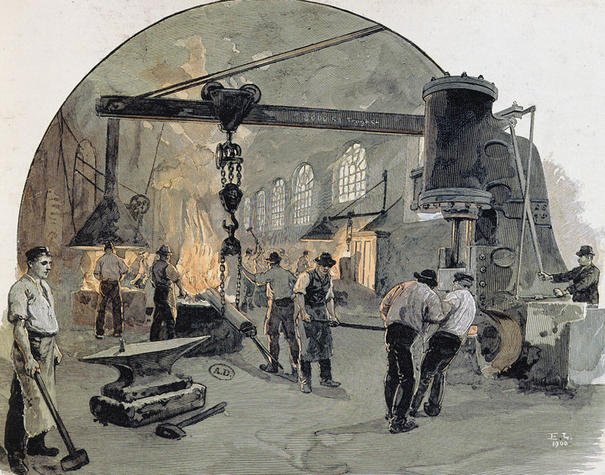
The Art Archive / Bibliothèque des Arts Décoratifs Paris / Collection Dagli Ort
This illustration depicts the metal works in Kiel, Germany. Although Germany began slowly, it industrialized rapidly in the second half of the nineteenth century, focusing especially on heavy industry.
Germany Germany began industrializing fairly late, in part because it consisted of a number of independent states for most of the 1800s. In 1834, however, many of those states joined in creating a free-trade zone. Germany soon established itself as a leader in heavy industry, especially metalwork. Using its abundant coal and iron ore, Germany produced the rails needed to establish an efficient railway system.
Railroads and their support industries, including steel-making, remained the leading sectors of the German economy through the 1800s. Late in the century, the chemical, electrical equipment, and weapons industries also prospered. By 1914, Germany was second only to the United States as an industrial power.
Japan Industrialized Western states used their wealth to build up a strong merchant fleet and navy. They sailed across the world in search of trade. Until the mid-1800s, Japan had kept itself isolated from outsiders. Now the increased contact by Westerners helped push the Japanese into a political revolution. The Japanese ousted the shogun, or strongest warlord, from power and restored their emperor to the throne, in what is called the Meiji Restoration.
The new government followed a course of modernization, using the West as a model. This included industrializing. The Japanese mechanized the silk-weaving industry and built railroads and ships. Japan quickly gained a position of economic dominance in East Asia. From its colonies and through concessions forced from China, Japan extracted needed resources, such as coal, and found markets for its industrial products.
NOTE BOOK ACTIVITY:
- 1. Complete the matrix below. For each country, list one similarity and one difference between their experience with industrialization and that of Great Britain.
